
I C F R
Guidance Notes for Rally Marshals

Contents
Planning a Rally 2
Deposits for site and Events………………………………………………………………………………………………….2
Rally Programme 2
Rotary Fellowship 2
New Members 2
Detailed Organization 3
Booking Form 4
Booking of Rallies 6
Legal Requirements of Rally Sites 6
Commercial Sites 6
Other Sites where the rally is not over five days 6
Other sites where the rally is for more than 5 days but less than 28 days 7
Safety spacing of units 7
Supervision of Rallies 8
Accidents and Insurance 8
Early arrivals on the rally field. 8
ICFR members on a rally site not booked into the rally who expect to join in. 9
Non ICFR Members 9
Visitors on the rally field 9
Food Hygiene 10
Data for the Rally Office 10
Other Considerations 10
Cancellation 10
Rally Signs 10
The President of ICFR 11
Special Rallies 11
Spring (AGM) and Autumn Fellowship Rallies 11
Recruiting Rallies 11
Conference Rallies 12
Rallies in National Parks 12
Extended Rallies 12
Additional requirements for Foreign Rallies 12
After the Rally 13
Financial Statement 13
Rally Report and Photos 13
Appendix 1 ACCEO IS11 Safety Spacing of Units 14
Appendix 2 Food Hygiene Risk Assessment 16

Planning a Rally
Congratulations! You have decided to run a rally. You will have researched a suitable location and site, and discussed possible dates with the site owner. You will have completed the online Offer to Run a Rally form and obtained agreement from the Programme Secretary. Now you want to know what to do next.
These Guidance Notes have been prepared to enable you to comply with relevant legislation and best practice so that you may run a successful rally. They have been collated from many years of collective experience in running rallies. Please read this booklet carefully before you do anything else. You can refer to the Asset Register for locations equipment that may be borrowed and order "ICFR Free Signs” including vital directional signs from Programme Secretary via the membership system.

Rally Programme
Fellowship is at the heart of rallies. You will probably want to encourage participants to visit local places of interest, possibly including a guided tour. Other social functions may include meals, BBQs and various types of activity that bring members together. Leaving at least one day and evening free for members to make their own arrangements is also an option. Organised in-van hospitality usually early in the programme helps to introduce members.

Rotary Fellowship
If you plan a visit to a local Rotary Club, you should make clear that it would be hoped that spouses and partners would be welcome. If not, then you should consider an alternative option.

New Members
Please give priority in accepting bookings from first time ralliers. The Programme Secretary can provide a special plaque which you are recommended to present at an early social function. Please also make a special effort with any new members on your rally. Their initial reception at a rally will determine whether they come on another one. Try to arrange a good pitch for them next to a member whom you have contacted to look after them. Make a point of introducing them to the member concerned and ask them to invite them in for a drink and take them to any social functions. Arriving at a rally for the first time amongst complete strangers can be a little daunting. The bigger the rally, the more important is this care.

Detailed Organization
Avoid restricting ralliers with a daily coffee morning after 10 a.m. Many members feel guilty if they leave the site before coffee, as a day starting at 11 a.m. can be a spoilt day.
Many Rally Marshals provide rally plaques as a memento but there is no obligation to do so. This is a matter for you to judge whether there are sufficient funds from rally fees (see below) to provide a plaque. Wharfedale & Bowie have been a regular supplier of ICFR plaques, but other companies are available.
You will want to greet everyone with an envelope containing a Rally Programme and local tourist information. Local tourist offices should be approached early in the season as they tend to run out of pamphlets later in the year. Ensure the programme gives details of the events you have arranged, so there is no misunderstanding which could spoil your rally. Please also include a list of members attending, together with their vehicle registration numbers. This will assist interaction and hospitality sessions.
An inclusive fee is unfair to those who cannot attend the whole rally or who may not wish to attend (e.g. for dietary reasons) some of the social events.
Please make sure you ask someone to write the rally report and take rally photos at the start of the rally. Arrange to send the report to the Editor of “ICFR News and Views” by email – target 300 words for UK rallies, 500 words for overseas ones.
Please remember that you are responsible for ensuring that data is held in a safe and secure manner, and that it should be destroyed once it is no longer required for the rally.

Rally Finances

Dealing with the Monies.
- Members' monies should not be paid into your personal account.
- Whenever possible a separate bank account should be opened with ICFR in the title. Details of this account should be included in your Offer to Run a Rally.

Deposits for Sites and Events.
- When discussing terms with site owner (dates, number of pitches and pitch price), or the event vendor, try to avoid paying a deposit
- If they do require one, determine the cost, the due date and when it becomes no longer refundable if cancelled.
- Aim to delay the due date until after January, when you will have had most of your applications and cancellation dates as late as possible,
- When you complete the Offer to Run a Rally form, state the terms of deposits required clearly.
- On your Rally Options document, state clearly that their place on the rally or chosen event is not guaranteed until the deposits are paid. Do not pay deposits for members, ICFR will not refund any losses incurred in this way.
- Advise the members, that when the deposit paid by them has been paid to the vendor, they are non-refundable after the cancellation date, unless resold and that the risk then lies with them as if they booked direct.
- Where a refund is requested and application money has been banked, you are entitled to deduct those expenses necessarily incurred from the refund. You may use your discretion on the amount to refund.
- The Programme Secretary should be consulted if you are uncertain how to proceed.
- It is important that any negotiations are carried out or confirmed by email, so that you can keep a record and there is no confusion. This protects the Rally Marshal, ICFR and the site or event vendor.
- If the site or event vendor insists on deposits and you are not comfortable with this, it may be best to choose another.

General Finance Advice
- Rally Marshals and Assistants are expected to pay the same as other ralliers, but are entitled to charge their reasonable expenses to the rally. It is certainly not intended that Rally Marshals should subsidize those attending.
- Rallies should not be used for fund raising (we do this in our own clubs). Visitors (including Rotary Clubs) should not be invited to the rally to put on events so that they can profit from the rally.

Rally Programme
This should detail the following:
- The venue, location and its post code. Directions and advice on using Satnavs if necessary.
- The provisional programme you have planned.
- Names and mobile numbers for the Rally Marshal and Assistant Rally Marshal during the rally.

Rally Options Form
- All costs should be included on form. Please make clear on the form the entire rally costs shown on the programme and if you don’t know any actual costs at the time of preparing the form, please state an estimated amount. Members should not be faced with unknown costs or unplanned events on arrival to which they may feel obliged to attend.
- At your discretion, you may take orders for papers and milk. Please state if you are prepared to accept tokens for newspapers.
- Please insert the following on the booking form: “ICFR has no insurance to cover loss or damage to outfits. Members attend this rally entirely at their own risk”.
- Members should be reminded to keep a copy of the Rally Options form.

The Rally Programme and Rally Options forms must be forwarded to the IT Secretary for inclusion on the website.

Booking of Rallies
You may not accept any applications for any UK rally before the Membership System applications opens at 6pm on the 1st of December.
The only exceptions are for:
- Overseas Rallies and both Fellowship Rallies where bookings of these rallies can take place as soon as they are approved and announced on the ICFR website or at Autumn Fellowship.
- RIBI, RI Conference Rallies which may be booked as soon as details are published for the Conference itself.
- NB: If a rally is oversubscribed and you need to select those who may take part, then the basis for this selection procedure should be completely transparent
- “First come, first served basis”. It is a long-standing expectation that acceptance of all rally applications is on a “first come, first served” basis. However, the responsibility and decision must always be with you the Rally Marshal as to whom you accept on your rally, particularly on overseas rallies where you may foresee a health problem as you are responsible for the enjoyment and safety of others on the rally.

Legal Requirements of Rally Sites

Commercial Sites

Most rallies are being held on commercial sites. These have a Local Planning Authority licence and we are entitled to rely on the site owners’ compliance with its conditions. Your rally may be for any number of nights. There are no special requirements.

Other sites where the rally is not over five days
ICFR has been granted a Certificate of Exemption from the need for planning permission. Natural England Certificate no.9 has been granted by the Secretary of State for the Environment under paragraph 6 of the Caravan Sites & Control of Development Act 1960 to cover rallies in England up to five days. Wales and Scotland issue their own certificates. This is issued by the Programme Secretary and must be available for inspection by a Local Planning Officer in the Rally Office throughout the rally. There are certain conditions:
- The Exemption Certificate covers paid up members only. This is evidenced by the completed rally booking forms. If Rotarian caravanners who are not members of ICFR present themselves at a rally covered by this Certificate they must NOT be allowed to stay over. You are entitled to refuse admission to any caravanner not displaying the ICFR Membership Sticker.
- Children or grandchildren of members may occupy vans with members or even occupy a small “pup” tent pitched alongside the caravan unit as an extension of the caravan accommodation. However, in no circumstances must a non-member’s van or tent be allowed on the site where our Exemption Certificate is used. Apart from being in breach of our certificate, this would invalidate our Public Liability Policy.
- If an overseas Rotarian caravanning in the UK should "drop in" to a rally, (it has happened!), please make him a temporary member of ICFR at a cost of £5.00. He must sign a simple form which states he is making application for temporary membership.
- Tents and trailer tents are not allowed on a rally field as separate units as ICFR does not hold the necessary Camping Exemption Certificate issued by Natural England.

Other sites where the rally is for more than 5 days but less than 28 days
We rely on a different Certificate of Exemption, no.9 issued under paragraph 4 of the Act. The above conditions apply, but there are additional requirements:
- The Programme Secretary will send the Rally Marshal a letter to send to the site owner, saying that we will have to enter into a Temporary Legal Agreement to rely on our Certificate of Exemption. The agreement pro forma requires the inclusion of the site OS grid reference.
- When this is returned to the Programme Secretary, the Rally Marshal should include the address of the Local Planning Authority.
- The Programme Secretary will inform the Local Planning Authority of the proposed rally. The Authority has the right to object to the rally.
- When confirmed, the Programme Secretary will send the Rally Marshal a copy of our Exemption Certificate (paragraph 4 version) for possible inspection during the rally as above.

Safety spacing of units
When setting out the site you must ensure that there is a minimum space of 6 metres in any direction between units, including any form of awning, except on commercial sites where pitches are already delineated. If space allows, an even greater distance between pegs is desirable. This creates a fire break and a clear access route for emergency vehicles. All units should face the same way to allow rapid and unconfused removal in an emergency. (See Appendix 1 ACCEO IS11 Safety Spacing of Units on page 14.)

Supervision of Rallies
The Rally Marshal is designated as the site supervisor. You should always be conscious of security on site and, whenever possible, ensure that someone is present throughout the rally. Where this is impractical all steps must be taken to make the units and site the least vulnerable to theft and damage.
You must be able to produce the copy Exemption Certificate, if applicable, as well as be able to demonstrate that only ICFR members’ vans are present.
At a previous ICFR rally eight caravans were broken into whilst most of the ralliers were at a social evening. Please do your best to ensure that it is not repeated on your rally. (See note on Accidents and Insurance below.)
As a matter of courtesy, the names of all visitors to the rally field, even if they are visiting ICFR members, should be signed in by using the Visitors Log in the rally office. The Rally Marshal is responsible during that rally for security and safety on site. You should be told if any rallier is going to be off site overnight and their van is unoccupied and they should leave a contact number.

Accidents and Insurance
The site must be checked for holes, rocks, broken posts and other items which might create an unseen hazard. All those found must be marked in the interest of safety. In the event of a possible claim against ICFR, you should make immediate contact with the ICFR Secretary, and provide full details.
ICFR has no Insurance cover for damage to or loss of caravans or rally tents. Our insurance is a Public Liability Insurance and as such we are required to exercise reasonable care. Members are responsible for their own insurance and everyone should ensure that they are adequately covered.
Caravans have been stolen from rallies. You are therefore asked to remind ralliers to use hitch locks and/or wheel clamps whilst on the rally and to set their alarm if fitted when they leave the site for any length of time.

Early arrivals on the rally field.
Please discourage members from arriving on the rally field earlier than the rally starting time.
On a Commercial Site it may be possible for a member who is going to arrive early to arrange with the Rally Marshal and book extra nights before (or after) the rally direct with the site. Those making such additional bookings are not your responsibility outside the published rally dates.
On a private or unlicensed site this is not possible and early arrivals must not be allowed. Where our Exemption Certificate is for a 5-day rally, this is strictly for 5 x 24-hour periods. If someone arrives 24 hours early, the rally must finish 24 hours earlier and everyone must be off the site earlier, because of one person’s actions.
Our Certificate does not insist on a 12 noon start and finish. Indeed several arrivals over your lunch period can be disruptive. Make your start time appropriate to the distance most ralliers must travel. However, on the day of departure most members have left by 11 a.m., so there is no reason why the rally cannot start earlier than say 12 noon or one o’clock, subject to the site owner’s consent. Probably an 11.00 a.m. start would be better, but the rally must end by the same time as it started. This may also help to eliminate the vexed question of early arrivals.
Please also remember that the Rally Marshal is allowed to go onto the site the day before, but this is limited to no more than one assistant's van per 20 units with a maximum of three vans. Again, you must first obtain the site owner’s agreement to this.

ICFR members on a rally site not booked into the rally who expect to join in.
ICFR members already on, or arriving on, a rally site who are not booked into the rally (particularly on any rally that may have been oversubscribed), may only join that rally as visitors. On non-commercial sites in the UK an acceptance could jeopardize the terms of our Exemption Certificate.
If you invite an ICFR member staying on the site to join the rally, where space is available, and which has not been oversubscribed, they must Apply and be Accepted via the Membership System, pay the full rally fee and the cost of any events they attend in advance.

Non ICFR Members
Non ICFR members including caravanning Rotarians are not permitted to stay on a rally in either a member’s caravan/motor home or their own unit, under the terms of our Exemption Certificate or insurance cover.

Visitors on the rally field
Visitors are always welcome on the rally field and they can be invited to join in any of the organized events without staying overnight. Encourage visitors to complete the Visitors Log to confirm who is on the site at any time. You do not need to return the Visitors Log with the Rally Financial Statement.

Food Hygiene
Please see Appendix 2 Food Hygiene Risk Assessment on page 16.

Data for the Rally Office
- Location of nearest public telephone and defibrillator.
- Location and emergency numbers for doctor, hospital, dentist, vet, police and breakdown services
- Availability of nearest caravan site for members who wish to stay longer in the area, plus caravan dealers and accessory shops, in particular suppliers of Calor/Gaz etc.
- Sporting and recreation facilities in the district.
- Places of interest to visit. (Local guide books are handy.)
- Places of worship and times of services.
- Days and times of meetings of local Rotary Clubs, with venue.
- Your mobile telephone number through which emergency contact can be made.
- A 1/50000 or 1/25000 map of the area.
- A copy of the Exemption Certificate if applicable.
- The “ICFR Rally” notice must be displayed at all times during the rally.
- Please make available the ICFR Visitors Log and remind members to sign in their visitors. Whilst not a requirement of our insurers, you will need to know what guests are on the site at any time.
- A Risk Assessment should be carried out and if there isn’t a copy in their rally pack, please make members aware of where it is and point out any major risks (see Accidents and Insurance page 8).

Other Considerations

Cancellation
If it should become necessary to withdraw or cancel a rally, you should immediately advise the circumstances to the Programme Secretary who will consult with the Rallies Committee before the decision is confirmed to ensure that there are no alternative options. Please recover site fees and other costs paid in advance to enable refunds to be made to disappointed members.

Rally Signs
Don’t forget to use ICFR directional signs to assist members in finding the rally site, these can be ordered on the membership System from the Programme Secretary. Please order these early in the year and at least six weeks before the commencement of your rally to give the Programme Secretary the best chance of fulfilling your order.
Please remember to remove ICFR directional signs after your rally. Failure to do so could result in prosecution by the Local Authority.

The President of ICFR
If the President of ICFR books in for your rally, they will wish to be treated the same as everyone else. However, it is courteous to try and give them a good pitch in the middle of the rally. At social functions when the President is present, he is the most senior person present and should be accorded that position. He should be invited by the Rally Marshal to introduce any guests including a District Governor or Club President, introduce any new members and issue their plaque, and address the gathering. He would also be expected to give the final vote of thanks.
This is particularly important at the large rallies such as the AGM and the Autumn Fellowship.

Special Rallies

Spring (AGM) and Autumn Fellowship Rallies
The President or Vice President inviting an Area to organize an Spring or Autumn Fellowship Rally will directly contact the Area or proposed Rally Marshal and provide them with personal requirements for the organization of these important rallies. If at all possible, these rallies should be open to all members with no booking limit.
Please make every effort to encourage non-caravanning members to attend the AGM and the Autumn Fellowship Rallies by providing details of nearby B & B accommodation and the telephone number of the local Tourist Office where information about local accommodation can usually be obtained.

Recruiting Rallies
If an Area Committee organizes a special Rally to publicize ICFR and recruit new members, these rallies must be held on commercial sites, so that the question of non-membership of ICFR and our Certificate of Exemption does not arise. Everybody attending such Rallies should book in and pay the site individually as ordinary site caravanners. If non-members are staying on that special rally or meet, each caravanner including the Rally Marshal is relying on their own personal insurance as our policy covers only events where all ralliers are ICFR members.

Conference Rallies
These rallies, too, are of course open to all members of ICFR, not just those from a particular Area (or Club), and an "Offer to run a Rally" must be submitted to the Programme Secretary, and approved by the Rallies Committee in the usual way. The rally will then be included in the list in “News and Views“. Any non ICFR Rotarian applying to attend must become a member because of the need for our Public Liability Insurance to apply. Remember to take some membership application forms.

Rallies in National Parks
Special approval by the appropriate National Park Officer must be sought to hold a rally in a National Park. This must be done through the Programme Secretary, who needs to receive notification of the Rally 18 months prior to the event to enable them to make application to ACCEO.

Extended Rallies
ICFR has been granted an Exemption Certificate to enable us to hold extended rallies on non-commercial sites up to 28 days. All members attending must be members of ICFR. (See the section on Legal Requirements of Rally Sites on page 6 for details.)

Additional requirements for Foreign Rallies
It is essential on all foreign rallies for Rally Marshals to obtain full details of participating members’ travel insurance cover including:
- Confirmation of holding Global Health Insurance cards GHIC from Gov.uk.
- Accident and medical insurance company name, policy number and contact telephone number
- Car and caravan insurers, policy numbers and contact telephone numbers.
- Next of kin in the UK, address and telephone numbers.
You should require all members to complete a pro-forma Emergency Information Sheet at least four weeks before departure from the UK with a declaration that they have full accident and medical insurance cover and are fit to join other members and indemnify the Rally Marshals against all liability.
You would be entitled to reserve the right to request sight of medical certification and if necessary exclude any member not prepared to comply with the above.
If you are running an overseas rally you are advised to appoint an Assistant Rally Marshal who should be made fully aware of all details and arrangements made for running your rally so that your Assistant can take over if necessary.

After the Rally

Financial Statement
Within three weeks of the end of the rally please send to the ICFR Treasurer the Financial Statement which should be submitted on the form provided, with receipts covering listed expenditures, a cheque or BACS payment for any surplus.

Rally Report and Photos
The Editor of "ICFR NEWS AND VIEWS" would like to receive a report with pictures on your rally by email – target 300 words for UK rallies, 500 words for overseas ones.

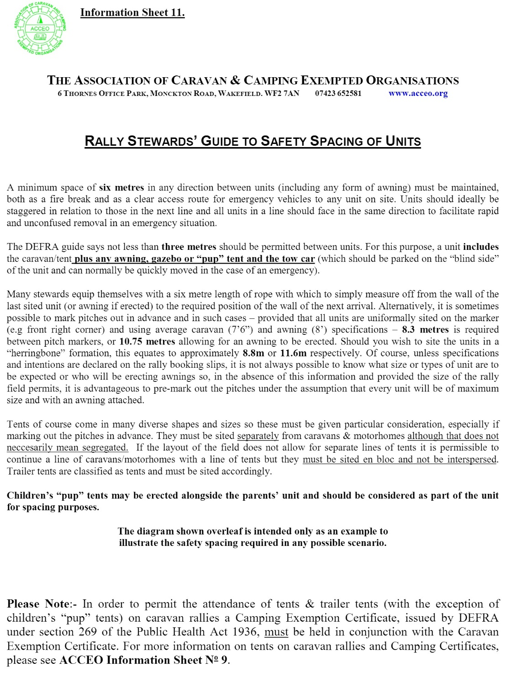
Appendix 1 ACCEO IS11 Safety Spacing of Units
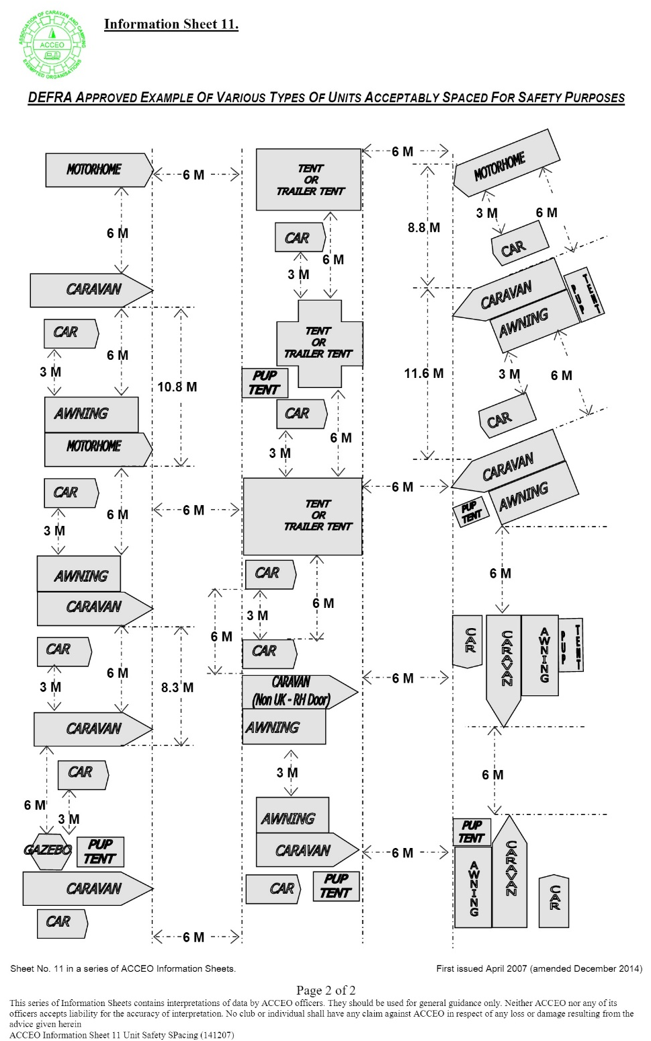

Appendix 2 Food Hygiene Risk Assessment
This risk assessment was prepared by PP Don Howard 30/5/2010
This guide/risk assessment is taken from published Health & Safety advice to help reduce the risk of food related illness, by using common sense and the following information.
In general, foods that need to be chilled (which include most of the foods people tend to serve on buffets and most sandwich fillings) should be left out of the fridge for the shortest time possible. If they are left at room temperature for a long time, bacteria can grow or toxins can form, and both of these could cause food poisoning. If you are preparing a buffet (or any other food) as part of a rally event, you must follow food safety regulations. The law requires caterers to keep certain foods at specified temperatures for food safety reasons. Chilled foods must be kept at or below 8°C, while foods that are being kept hot before serving should remain at or above 63°C.
The law allows food to be left at room temperature for limited periods during service or when on display. The temperature of chilled foods can exceed 8°C for up to four hours depending on ambient temperature. The temperature of hot foods can fall below 63°C for a maximum of two hours. However, these flexibilities can be used only once for each batch of food. In other words, the same food can't be left out at room temperature for more than one period, even if the separate periods add up to a combined total of four (or two) hours. After one period at room temperature, food should be thrown away or chilled until final use.
1. Are the food handlers experienced, trained and competent to handle food?
- Most people are competent, but it is advisable to have some form of training. A Basic Hygiene Certificate can be taken on line at minimal cost.
- Personal hygiene is a must; all hands to be washed before and after handling different foods.
- Any person with stomach complaints or infectious diseases must not take part.
- A clean protective garment must be worn. (Disposable gloves for the food trade may be worn).
- Long hair must be tied back or netted.
2. Purchase of food.
- All foods should be purchased from a reputable supplier and transported in a manner appropriate so that no spoilage occurs. (All receipts should be kept.)
- Frozen foods if not being used at once should be kept below -16°c.
- Chilled foods ideally to be below 5°c.
3. Are you preparing food onsite? If so:
- You will need hot and cold water with separate facilities for hand washing and cleaning kitchen utensils.
- What is the nature of the foods prepared? Do you need a fridge or freezer?
- Are there facilities for washing and the preparation of foodstuffs?
- Is the preparation and serving area clean?
- Is there room for the separation of the food stuffs? Separate cooked foods from raw food.
4. Protecting food from contamination
- Keep food covered wherever possible.
- Do not use damaged or dirty equipment.
- Inspect all equipment before use.
- Clean and sanitize with antibacterial spray all work surfaces before and after use.
- Sanitation can be achieved by using very hot water or a sterilizing agent.
- Raw and cooked foods must be kept separate at all stages at of preparation.
- Storage and distribution: ideally the same equipment and work surfaces must not be used for raw and cooked foods.
- Where this is unavoidable, equipment and surfaces must be thoroughly washed and sanitized in between uses.
5. Cooking of food.
- BBQ. Make sure burgers and sausages are cooked right through, i.e. not pink in the centre.
- Chicken must also be thoroughly cooked.
- Cooking of meat and poultry in an oven should be cooked to an internal temperature of 72°c checked by way of a meat thermometer.
- Be aware of any dietary requirements, make a note and keep this food in an allocated place away from main food stuffs.
- Be aware that the kitchen has hot liquids and surfaces. Any spillage should be cleaned immediately.

HIGH RISK FOODS
FOOD TYPE | BACTERIA | PREVENTIONS
Ice Cream | Salmonella  Staphylococcus Aureus | Eat immediately or keep in freezer until required Keep in fridge/cool box for 1-2 hours  DO NOT REFREEZE ONCE DEFROSTED
Cream/Yoghurt  Creamy Deserts | Salmonella  Staphylococcus Aureus | Keep chilled & eat within 1-2 hours of purchase or store in cool box for maximum 24 hours
Cooked Meat or Poultry | Campylobacter  Salmonella  e.Coli | Always defrost before cooking. Ensure fully cooked.  Eat immediately or chill and store in fridge  Eat within two days of cooking if kept at chilled temperature  MUST BE EATEN WITHIN 2 HOURS IF NOT CHILLED
Cooked Meat products (i.e. stews/soups and sauces) | Campylobacter  Salmonella  e.Coli  Clostridium perfringens | Eat immediately or cool to below 5°c.  When reheated should reach above 63°c.  DO NOT LEAVE IN PAN ON STOVE UNLESS HEAT REMAINS ON
Fresh Milk/Cream | Salmonella Staphylococcus Aureus | Should always be kept at chilled temperature. DO NOT LEAVE IN AMBIENT TEMPERATURES
Seafood | Scombroid toxin (Temperature control is very important to avoid this) | Must be kept chilled before cooking or eating  Ensure that the fish is fully cooked.  Fish can be cooked from frozen but ensure fully cooked in the centre.  Shellfish must be kept fully chilled
Cooked Rice/Pasta | Bacillus cereus | Rice/pasta is very low risk before cooking but once cooked becomes high risk  Eat as soon as cooked or chill & reheat to 70°c or above  Chill rapidly in cold water  DO NOT LEAVE TO CHILL
Vegetables/Salads | E.coli  Listeria Shigella | Salads and vegetables must be washed well to remove any dirt. Peeling and re-washing will also help to minimise any risk. Cooking vegetables will destroy the bacteria
Tins (these products have a botulinum. Cook at 121°c for 3 mins) | Clostridium Botulinum | Damaged, blown or leaking cans should never be used - dispose of them
Cooked Eggs | Salmonella | Eat eggs whilst hot or hard boiled  Chill rapidly and keep chilled before eating  ALWAYS WASH HANDS AFTER HANDLING RAW EGGS

